
Society of St. Francis Xavier, Pilar’s
Fr. Conceicao Rodrigues College of Engineering
Fr. Agnel Technical Education Complex Bandstand,
Bandra Mumbai -400 050
______________________________________________________________

Department of Artificial Intelligence & Data Science

B.E. Project Proposal Format
2026 - 2027
- Name of the student(s) with roll numbers
Member | Roll Number | Name of the student
1.(Group leader) | 10365 | JOSHUA PARMAR
2. | 10377 | JOHNSON SERRAO
3. | 10343 | GODFREY FERNANDO
4. | 10099 | BRISTO JOSEPH
- Title of the Project: Intelligent GPU Cluster Observability and Predictive Maintenance Platform using AIOps OR AIOps-Based Intelligent GPU Cluster Observability Platform for Predictive Maintenance and Resource Optimization
- Project Category:
Research | √ | Software | √
Application | √ | Hardware
Product | √ | Software and Hardware

- Project Domain(s):
- Artificial Intelligence for IT Operations (AIOps)
- Cloud Computing & Data Center Infrastructure
- GPU Cluster Management & High-Performance Computing (HPC)
- Predictive Maintenance & Anomaly Detection
- Distributed Systems
- Time-Series Analytics
- Explainable Artificial Intelligence (XAI)

- Project Abstract:
The rapid adoption of Large Language Models (LLMs), Generative AI, and high-performance computing has led to the deployment of massive GPU clusters within modern AI data centers, where thousands of Graphics Processing Units (GPUs) operate simultaneously to execute computationally intensive workloads. Ensuring the reliability, availability, and optimal utilization of these GPU resources has become a significant operational challenge, as conventional infrastructure monitoring platforms primarily rely on static threshold-based alerts and manual analysis of telemetry data. Such approaches are often reactive in nature, making it difficult for infrastructure teams to identify subtle performance degradation, detect anomalous GPU behavior at an early stage, determine the root cause of failures, and optimize resource allocation before service disruptions occur.
This project proposes an Enterprise AIOps Platform for Intelligent GPU Infrastructure Management, designed to provide autonomous observability, predictive maintenance, and intelligent decision support for large-scale GPU clusters. The proposed system continuously collects GPU telemetry, including utilization, temperature, power consumption, memory usage, clock frequencies, ECC error statistics, and other operational metrics through NVIDIA's monitoring interfaces. The collected telemetry is stored within a scalable time-series database and analyzed using Artificial Intelligence and Machine Learning techniques to model normal GPU behavior, identify anomalies, estimate hardware health, and predict potential failures before they impact ongoing workloads.
Unlike existing GPU monitoring solutions that primarily visualize operational metrics, the proposed platform incorporates an AI-driven analytics engine capable of anomaly detection, predictive maintenance, GPU health scoring, explainable root cause analysis, and intelligent workload optimization recommendations. Explainable Artificial Intelligence (XAI) techniques will be integrated to provide transparent reasoning behind every prediction, enabling infrastructure administrators to understand the factors contributing to abnormal GPU behavior and make informed operational decisions. The platform will further prioritize alerts based on severity, recommend proactive maintenance actions, and suggest workload redistribution to healthier GPU resources in order to improve cluster reliability and operational efficiency.
The proposed system will be implemented using a FastAPI-based backend, React-based enterprise dashboard, PostgreSQL and TimescaleDB for telemetry management, and modern Machine Learning frameworks such as Scikit-learn and PyTorch for predictive analytics. Since access to production-scale GPU data centers is impractical in an academic environment, the project will combine real GPU telemetry collected through NVIDIA Management Library (NVML) interfaces with realistic workload simulations and fault injection techniques to emulate large-scale infrastructure scenarios. The developed platform will be evaluated using performance metrics including anomaly detection accuracy, prediction precision, alert latency, health score consistency, and system responsiveness. The scope of the current project is limited to intelligent monitoring, predictive maintenance, and decision support for GPU infrastructure, while autonomous workload migration, hardware-level fault recovery, and deployment within production-scale data centers are identified as future enhancements.

- Objectives of the project:

- Develop an AI-powered GPU infrastructure observability platform that continuously collects and analyzes real-time GPU telemetry, including utilization, temperature, memory usage, power consumption, and other operational metrics to monitor the health of GPU clusters.
- Design and implement an intelligent anomaly detection and predictive maintenance framework that identifies abnormal GPU behavior, estimates GPU Health Scores and Failure Risk Scores, and provides proactive maintenance recommendations using Machine Learning and Explainable AI techniques.
- Build an interactive enterprise monitoring dashboard that visualizes real-time GPU health, cluster performance, anomaly alerts, historical telemetry trends, and AI-generated insights to support efficient decision-making for data center administrators.

- Project Structure Diagram:
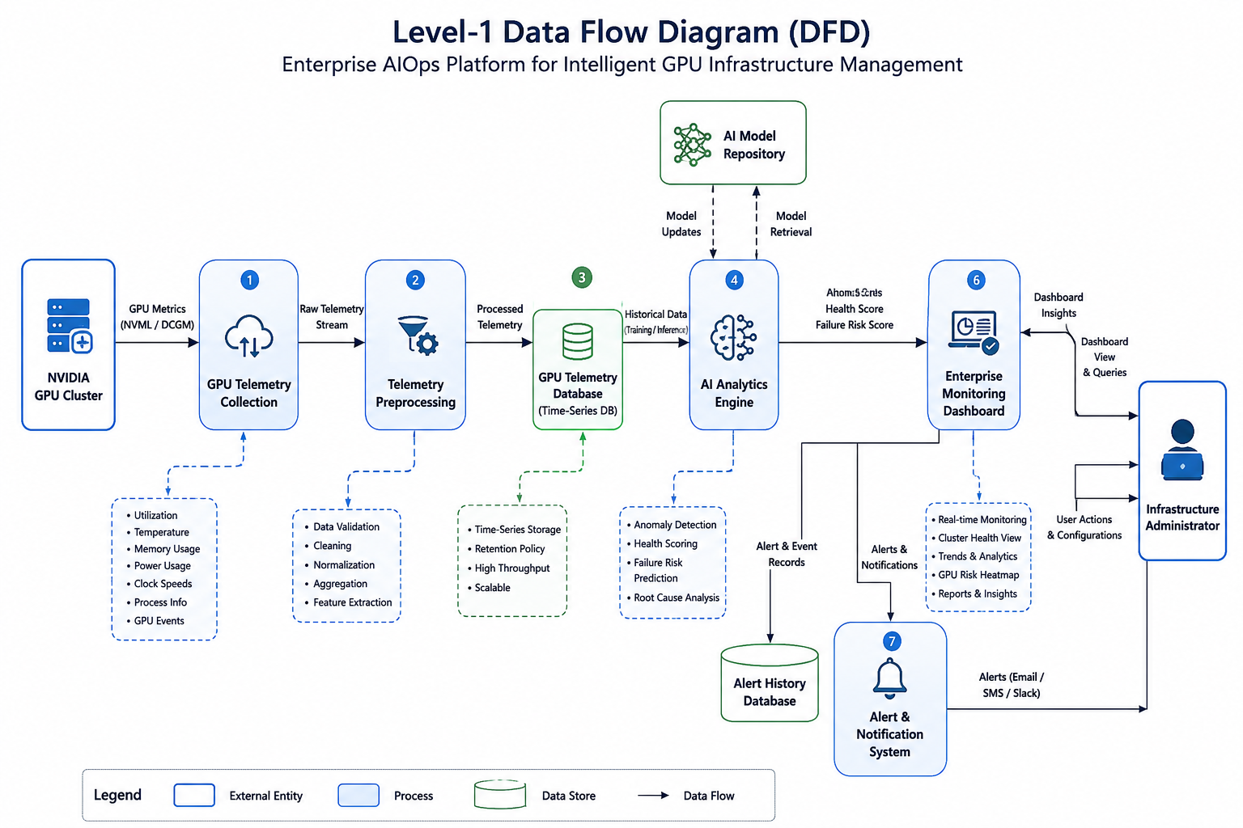
Figure 1: Project Structure Diagram
Figure 1 illustrates the architecture of the proposed Enterprise AIOps Platform for Intelligent GPU Infrastructure Management. The system begins by collecting real-time telemetry data from NVIDIA GPU clusters using NVIDIA Management Library (NVML) and NVIDIA Data Center GPU Manager (DCGM). The collected telemetry includes GPU utilization, temperature, memory usage, power consumption, clock frequencies, process information, and other hardware health metrics required for continuous infrastructure monitoring.
The collected telemetry is then passed to the Telemetry Preprocessing module, where the data undergoes validation, cleaning, normalization, and feature extraction to improve data quality and prepare it for Machine Learning analysis. The processed telemetry is stored in a centralized GPU Telemetry Database, which maintains both real-time and historical performance records for trend analysis and model training.
The processed data is subsequently analyzed by the AI Analytics Engine, which employs Machine Learning algorithms to learn normal GPU behavior, detect anomalous operational patterns, estimate GPU Health Scores, and calculate Failure Risk Scores. The analytics engine interacts with the AI Model Repository to retrieve trained models and continuously improve prediction accuracy using historical telemetry data.
The generated insights are forwarded to the Decision Support Engine, which performs intelligent root cause analysis, prioritizes alerts based on severity, and generates proactive maintenance recommendations to help administrators prevent potential GPU failures and optimize overall cluster performance. All generated alerts and recommendations are archived in the Alert History Database for future analysis and auditing.
Finally, the processed information is presented through the Enterprise Monitoring Dashboard, which provides infrastructure administrators with real-time visualization of GPU health, anomaly alerts, historical telemetry trends, cluster utilization, and AI-generated insights. Critical events are simultaneously delivered through the Alert & Notification System using channels such as email, SMS, or Slack, enabling timely intervention, minimizing downtime, and improving the reliability, availability, and operational efficiency of large-scale AI data center infrastructure.

- System Requirements:

Hardware Requirements:
- Processor: Intel Core i5 (10th Generation or above) / AMD Ryzen 5 or equivalent
- RAM: Minimum 16 GB (32 GB Recommended)
- Storage: Minimum 512 GB SSD
- GPU: NVIDIA GPU with CUDA support (GTX/RTX Series or Data Center GPU preferred for telemetry collection)
- Internet Connectivity: Stable broadband connection for software installation, updates, and cloud integration

Software Requirements:
- Operating System: Windows 11 / Ubuntu 22.04 LTS (Preferred)
- Programming Language: Python 3.11+, TypeScript, JavaScript
- Backend Framework: FastAPI
- Frontend Framework: React.js
- UI Framework: Tailwind CSS
- Database: PostgreSQL with TimescaleDB Extension
- Machine Learning Libraries: Scikit-learn, PyTorch
- GPU Monitoring Libraries: NVIDIA Management Library (NVML), NVIDIA Data Center GPU Manager (DCGM)
- Data Visualization: Recharts / Chart.js
- API Testing: Postman
- Version Control: Git & GitHub
- Development Environment: Visual Studio Code
- Containerization: Docker & Docker Compose (Optional)

Development Tools:
- NVIDIA CUDA Toolkit
- NVIDIA Drivers
- Python Virtual Environment (venv)
- Jupyter Notebook (for experimentation and model development)

Target Deployment Environment:
- Local Workstation with NVIDIA GPU
- On-Premise GPU Server or Cloud-Based GPU Instance (Future Scope)

References (IEEE Format):
[1] Z. Liu et al., “Interpretable Analysis of Production GPU Clusters Monitoring with Large-scale Telemetry,” in Proceedings of the IEEE/ACM International Conference on High Performance Computing, Networking, Storage and Analysis (SC), 2024.
[2] M. A. Ahmed, A. S. Ahmed, and A. M. Mohamed, “Deep Learning for Anomaly Detection in Time-Series Data: Review, Analysis, and Guidelines,” IEEE Access, vol. 9, pp. 132114–132141, 2021.
[3] A. B. M. Moniruzzaman et al., “Utilizing AIOps for Predictive Maintenance in Hybrid Cloud Environments,” in Proceedings of the 2023 IEEE International Conference on Cloud Computing Technology and Science (CloudCom), 2023.
[4] J. Zhang et al., “Time Series Anomaly Detection for Trustworthy Services in Cloud Computing Systems,” IEEE Transactions on Big Data, vol. 8, no. 1, pp. 60–72, 2022.
[5] J. F. Gomes, F. C. Santos, and E. C. Ferreira, “Explainable Artificial Intelligence for Predictive Maintenance Applications,” IEEE Access, vol. 8, pp. 188171–188182, 2020.
[6] NVIDIA Corporation, “NVIDIA Data Center GPU Manager (DCGM) Documentation,” 2026. [Online]. Available: https://docs.nvidia.com/datacenter/dcgm/latest/
[7] NVIDIA Corporation, “NVIDIA Management Library (NVML) API Reference.” [Online]. Available: https://developer.nvidia.com/management-library-nvml
[8] NVIDIA Corporation, “CUDA Toolkit Documentation.” [Online]. Available: https://docs.nvidia.com/cuda/

